**Developing Soft and Parallel Programming Skills Using Project-Based Learning**

Fall 2019

TGI-Pi Day

Tony Derado, Samson Gebreegziabher, Raksiht Patel, Quan Uong, Katya Wright

|  |  |  |  |  |  |  |
| --- | --- | --- | --- | --- | --- | --- |
| Assignee Name | Email | Task | Duration | Dependency | Due Date | Notes |
| Quan Uong | quong1@student.gsu.edu | - Completed Task 3A  - Participated in Task 6 | _ hours | To be completed before or soon after meet-up | 09/25/19  by EOD | Did the assigned tasks |
| Katya Wright  (coordinator) | kwright41@student.gsu.edu | - Completed Task 1 (Planning and Scheduling)  - Completed Task 2 (slack: added TA/ GitHub: assigned tasks)  - Participated in Task 6 | _ hours | Priority to be completed before anything else | 09/25/19  by EOD | Did the assigned tasks |
| Rakshit Patel | rpatel167@student.gsu.edu | - Completed Task 3B  - Completed Task 4  - Participated in Task 6 | _ hours | To be completed before or soon after meet-up | 09/01/19at EOD | Did the assigned tasks |
| Samson Gebreegziabher | sgebreegziabher2@student.gsu.edu | - Edited the video for Task 6  - Participated in Task 6 | _ hours | none | 09/29/19  by EOD | Did the assigned tasks |
| Tony Derado | tderado1@student.gsu.edu | - Composed the report for Task 5 | 4 hours | none | 10/04/19  By EOD | Did the assigned tasks |

**Section 1: Planning and Scheduling**

The work table for the 2nd project, including the members, their contributions and assigned tasks.

**Section 2: Parallel Programming Skills**

The components on the raspberry PI B+:

The raspberry PI B+ has two USB ports, an ethernet port, 2 power ports, a camera, HDMI port, an ethernet Controller, CPU/RAM, and a display port.

How many cores does the Raspberry PI’s B+ CPU have?

The Raspberry PI’s B+ CPU contains 4 cores.

The three main differences between x86 (CISC) and ARM Raspberry PI (RISC):

The Intel’s CISC has a larger and more feature rich instruction set, allowing for many complex instructions to access memory with more operations. CISC has more addressing modes but less registers than RISC. CISC also uses little-endian format for storage. ARM’s RISC has a simplified instruction set, with more general-purpose registers than CISC. Therefore, with simplified instructions, RISC is executed quicker. However, with less instructions, RISC emphasizes the efficiency of writing. RISC’s instructions only operate on registers and uses Load/Store for memory access. RISC is stored with BI-endian meaning that it can switch between small and big endian.

What is the difference between sequential and parallel computation and what is the practical significance of each?

Traditionally, software has been written for serial computation. The problem is broken into a discrete series of instructions, then they are executed sequentially one after another. All instructions are executed on a single processor, allowing only one instruction to execute at the time. The significance of sequential computing is the simplicity of writing instructions.

In the simplest sense, parallel computing is the simultaneous use of multiple compute resources to solve a computational problem. The problem is broken into discrete parts that can be executed concurrently. Each part is broken into series of instructions, they then execute simultaneously on different processors. The practical significance of parallel computing is the speed at which instructions are executed.

Identify the basic form of data and task parallelism in computational problems:

Data parallelism refers to a broad category of parallelism, in which same computation is applied to multiple data items. The same tasks are applied over multiple streams of data on different cores.

Task Parallelism applies to solutions where parallelism is organized around the functions to be performed rather than around the data. Task parallelism allows one to compute one task on one core and a different task on another.

What are the Differences between processes and threads?

Processes are the abstraction of a running program, they do not share memory with each other, and can only operate one per core. While threads are lightweight processes that allow executables to be decomposed into independent parts and share a common memory with the process they belong to.

What is OpenMP and OpenMP pragmas?

OpenMP is a library/language for programming multicore architecture which uses an implicit multithreading model in which the library handles thread creation and management, thus making the programmer’s task much simpler and less error-prone.

OpenMP pragmas is the compilers directive that enables the compiler to generate threaded code.

What applications benefit from multi-core?

Applications that benefit from multicore usage include but are not limited to database servers, web servers, multimedia application, and scientific applications (CAD/CAM).

Why use multicore?

Single core can only operate one process at the time, while multi cores are capable of concurrently running multiple processes at once, reducing the time to complete and increasing the output of the system. Also speeding up the clock frequencies in single core is difficult due to heat problems, maximum speed of light, and costs. Finally, many new applications are multithreaded to utilize multicores.

**Section 3: ARM Assembly Programming**

**Task 3 (B): Parallel Programming Basics**

We were given code for C language which basically prints the multiple threads on different core of the multicore machine. And we tried the different entrees also. The problem the code had in the first section was that int id was declare din main method. When we ran the code, we saw that the id number is appearing more than once.

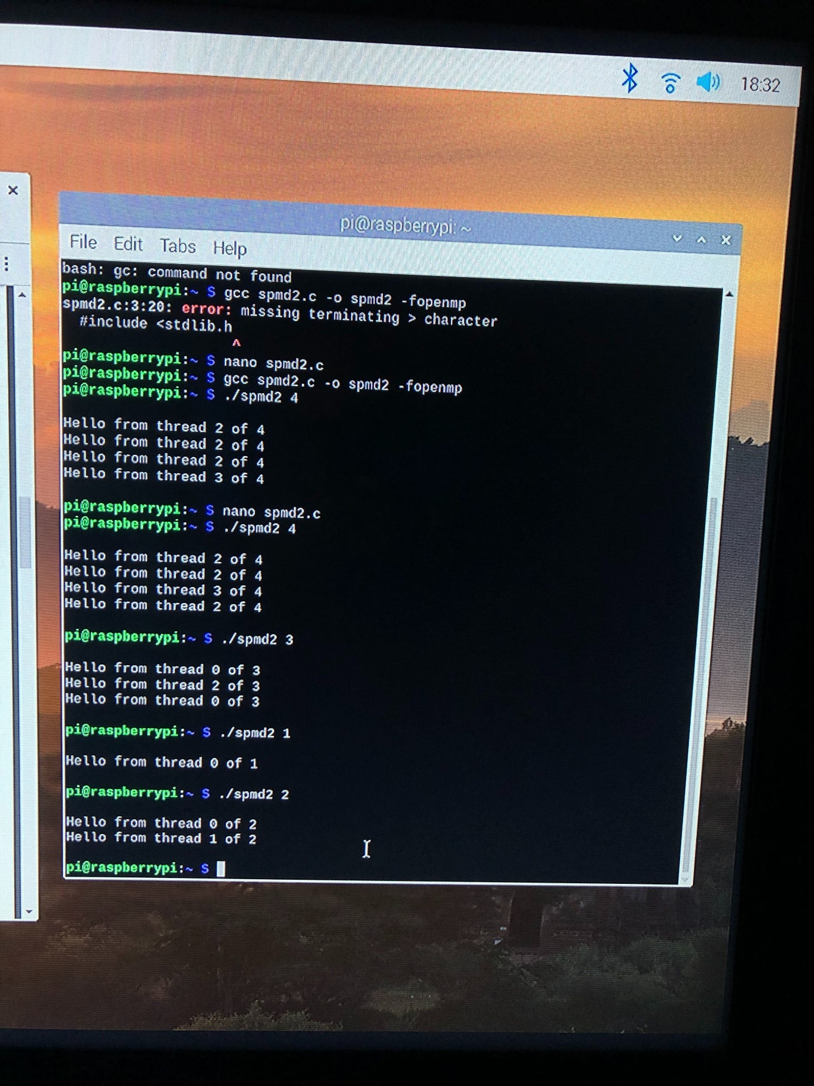

**Task 4: ARM assembler in Raspberry Pi**

**Part 1 - Second program**

After setting up the raspberry Pi on TV. I proceeded to follow the tasks to practice coding in ARM Assembler.



we wrote and saved the following program:

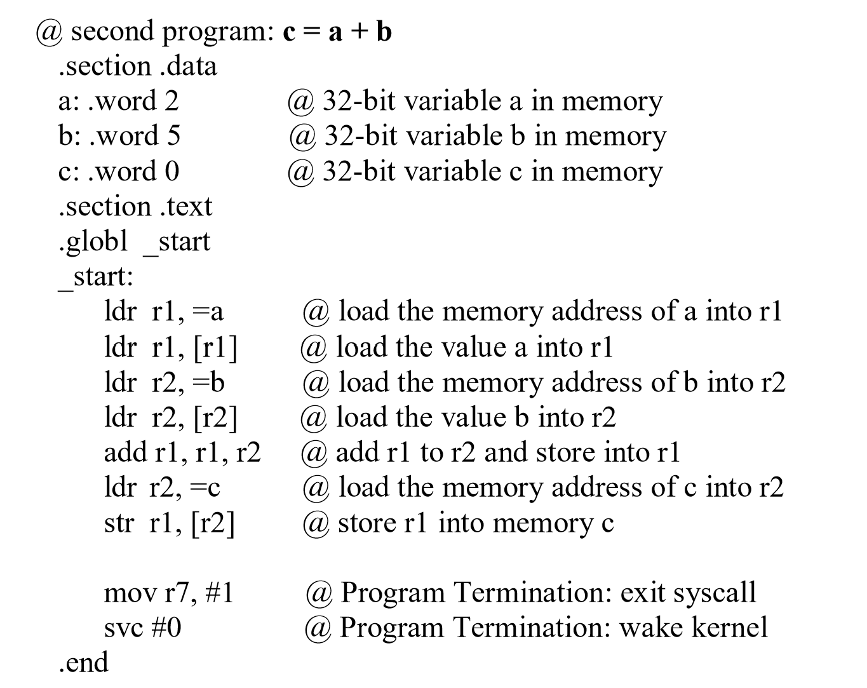

After composing the file, we then assembled and linked it in order the receive an executable file. Then we executed it. No output though. The entire program takes place in the registry, we will not receive any output.

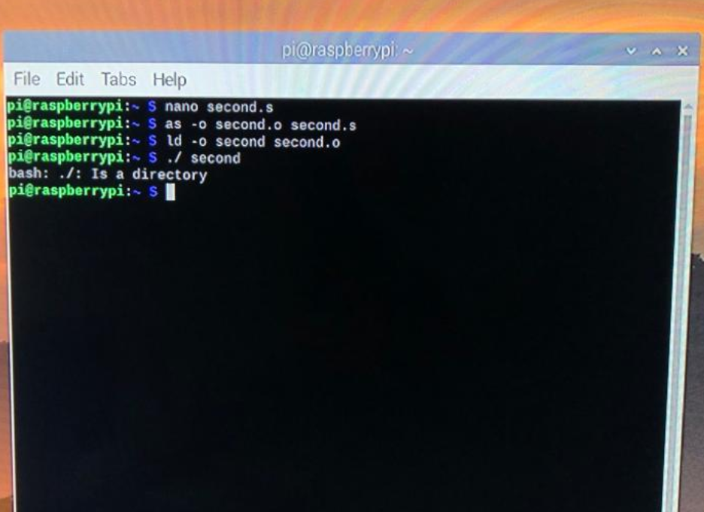

Next, we practiced utilizing the GDB (GNU DeBugger) in order to get an idea on how our First Program was being executed. Preparing to use the GDB required us to re-assemble the program with an additional flag “-g”. No additional steps were needed when the program was re-linked. After the new executable was generated, we launched the GDB with the file named “first” which we wished for the debugger to examine (utilizing “gdb first”).

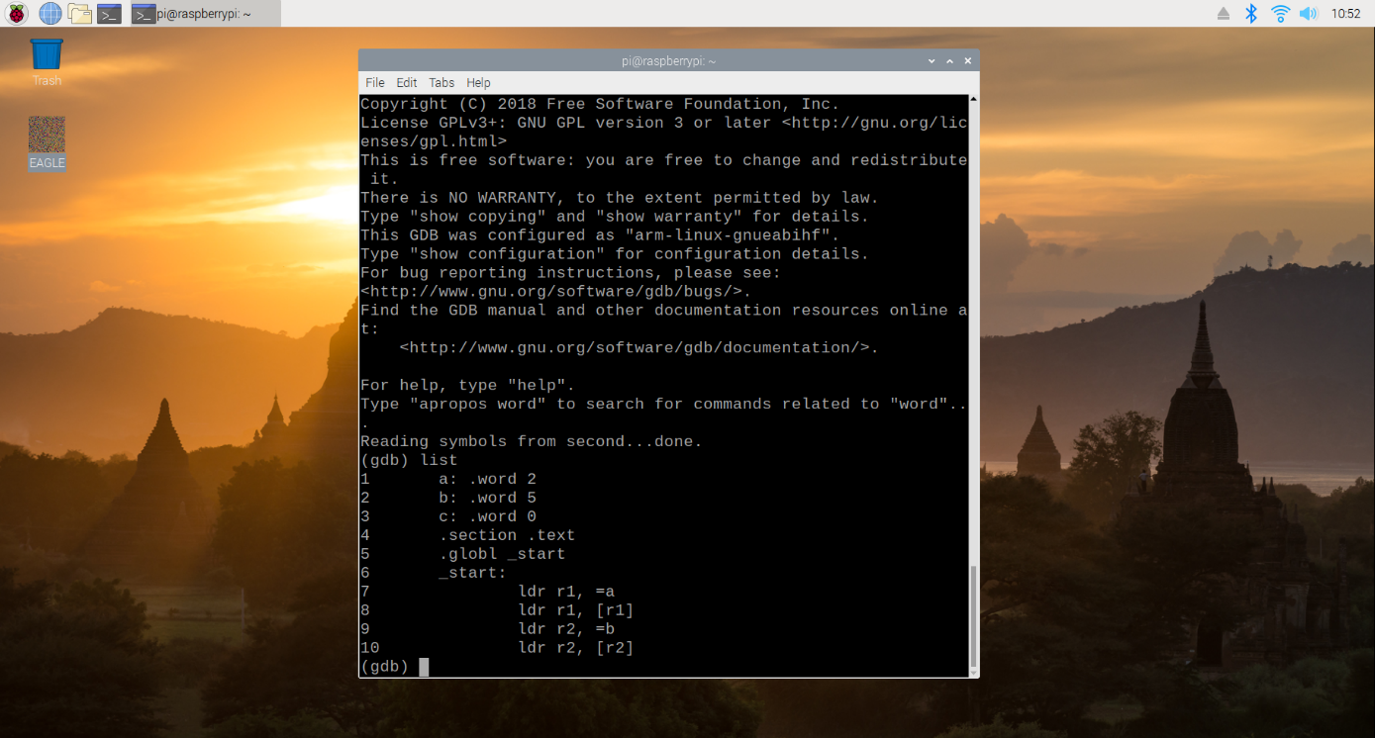

If the program already executes as expected, the debugger provides less information without an additional step, setting a breakpoint. We were able to see how the program was completing its tasks. To stop the program prior to the execution of line 15, we gave the GDB the command “b 15”, and then we ran the program from its beginning until the breakpoint utilizing “run”.

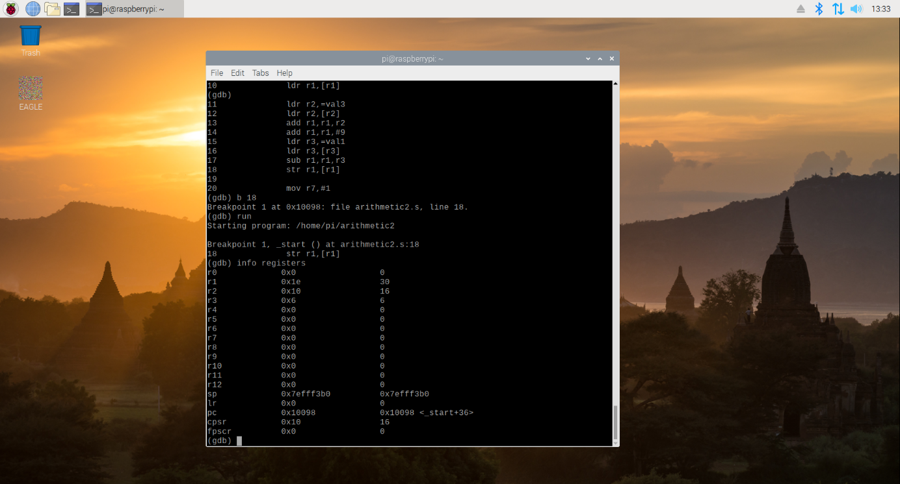

In order to see the generated values in the CPU registers (before line 15 was executed), we needed to utilize the command “info registers”. As we know the vales in the register a=2 b=5, c=0 then we build the program to run the code and ger results in c=a+b.

**Part 2 - Calculate the Expression**

With this better understanding of the process, we began Part 2 in which we created, assembled, linked, ran, and debugged our own program which calculated the expression Register = val2 + 9 + val3 – val1 where Val1=06, Val2=11, Val3=16.

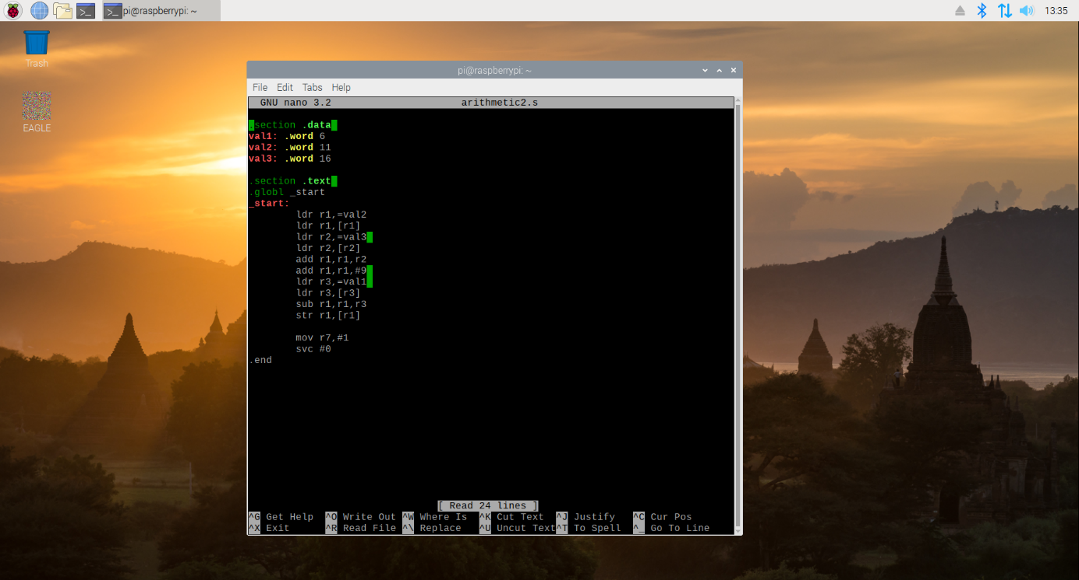

As in Part 1, we composed the program through the terminal with nano text editor, before assembling it. When composing a program, an extra, empty line must be included following the end of the program, or the assembler will take it upon itself to add the line for the user.

After assembly, we linked the program to create the executable file and ran that file.

For reference, the program we utilized was as follows:

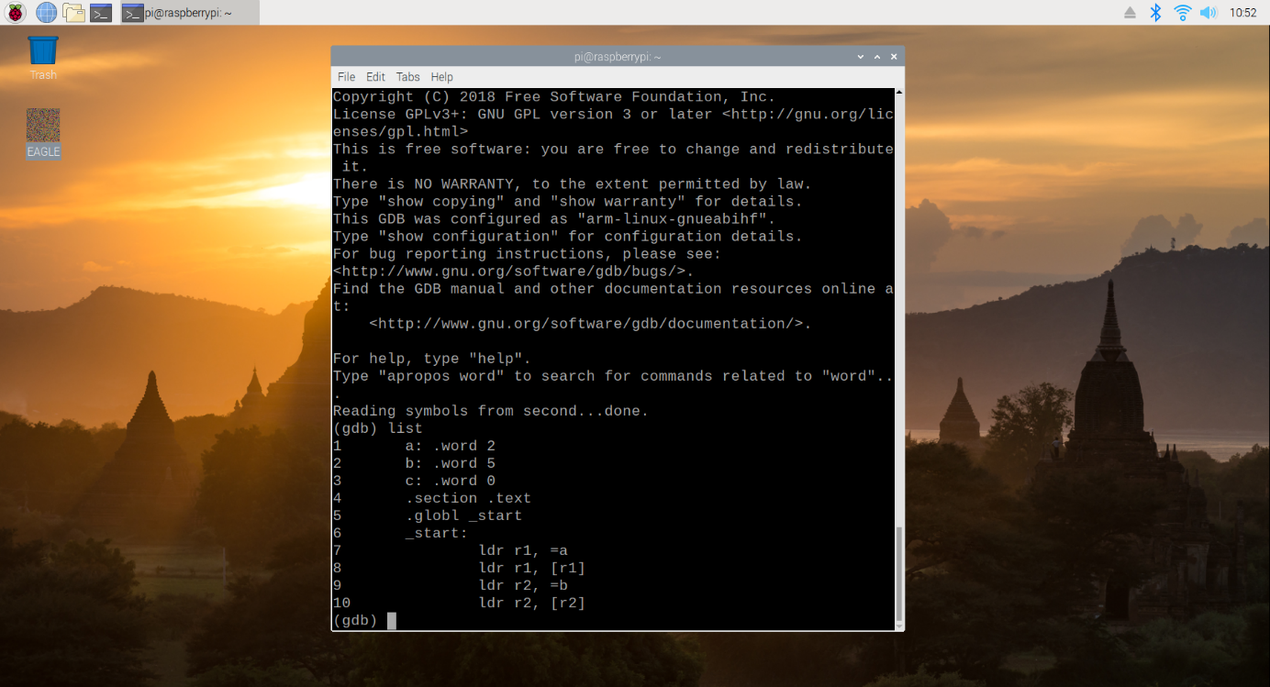

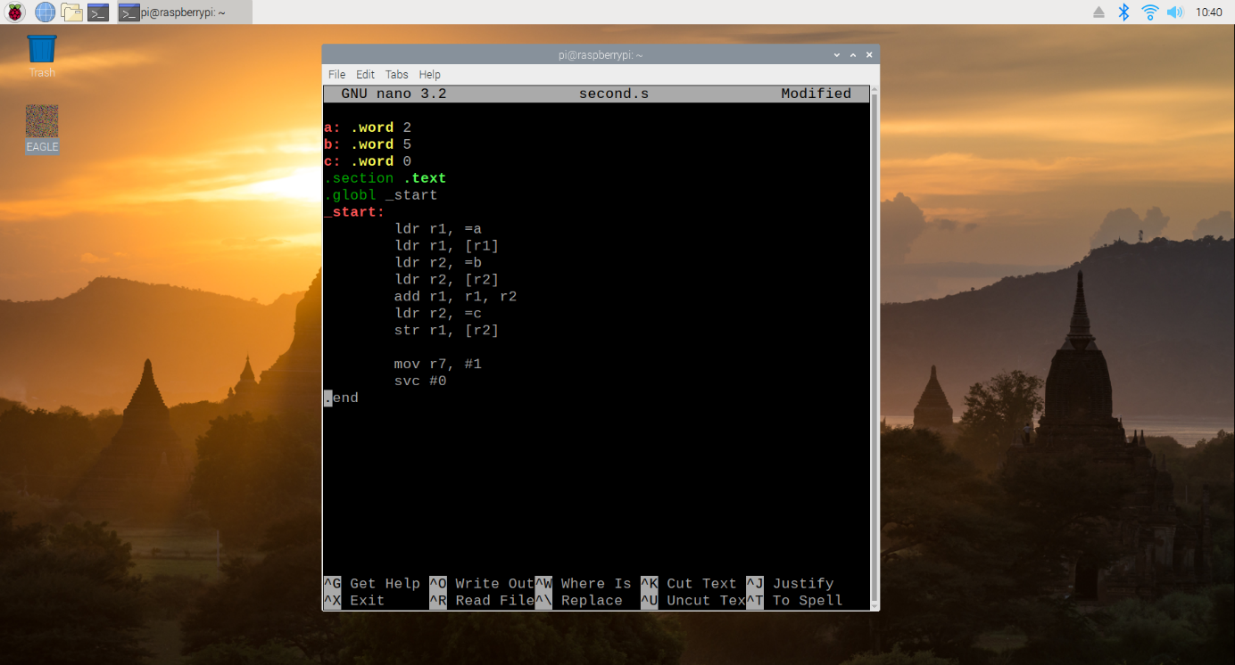

As with before, we were not able to “see” the program at work, so again we used the GNU Debugger to get a better idea of how our program was functioning.

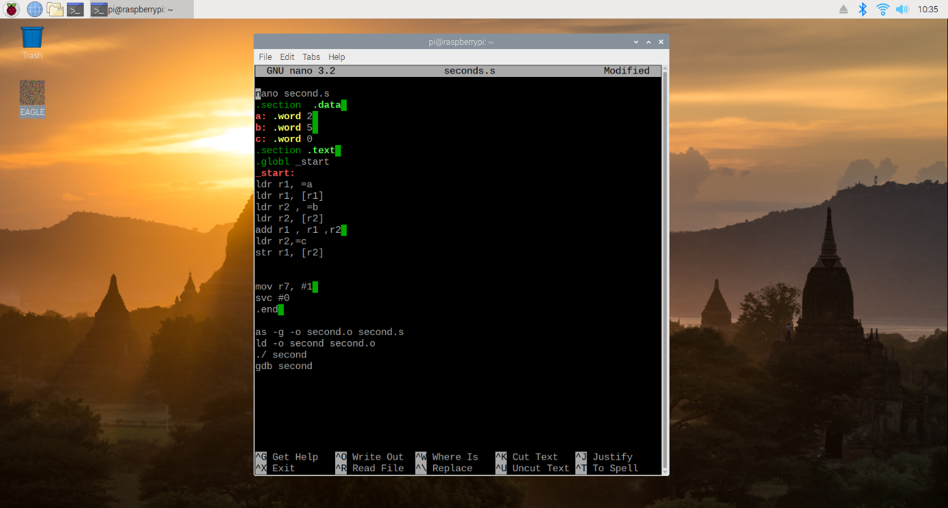

We then ran the program before utilizing the “info registers” command (whose results are shown in the next figure).

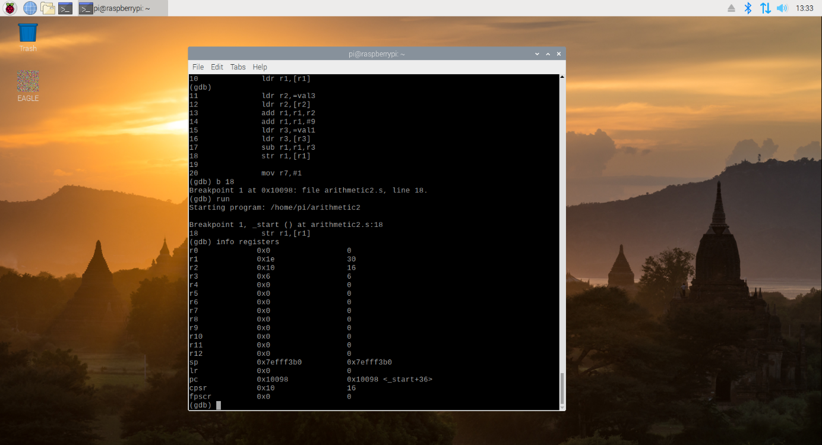

Comparing the values stored in the register, we could see that each of the values were expected. Registers 1 through 3 held the values 30, 16, and 6 which were their assigned values. Register 1 held the value of 30 - the result of our initial val2 + 9 + val3 – val1.

**Section 4: Appendix**

The following are the required supporting material for this assignment:

* Slack: <https://tgi-piday.slack.com>

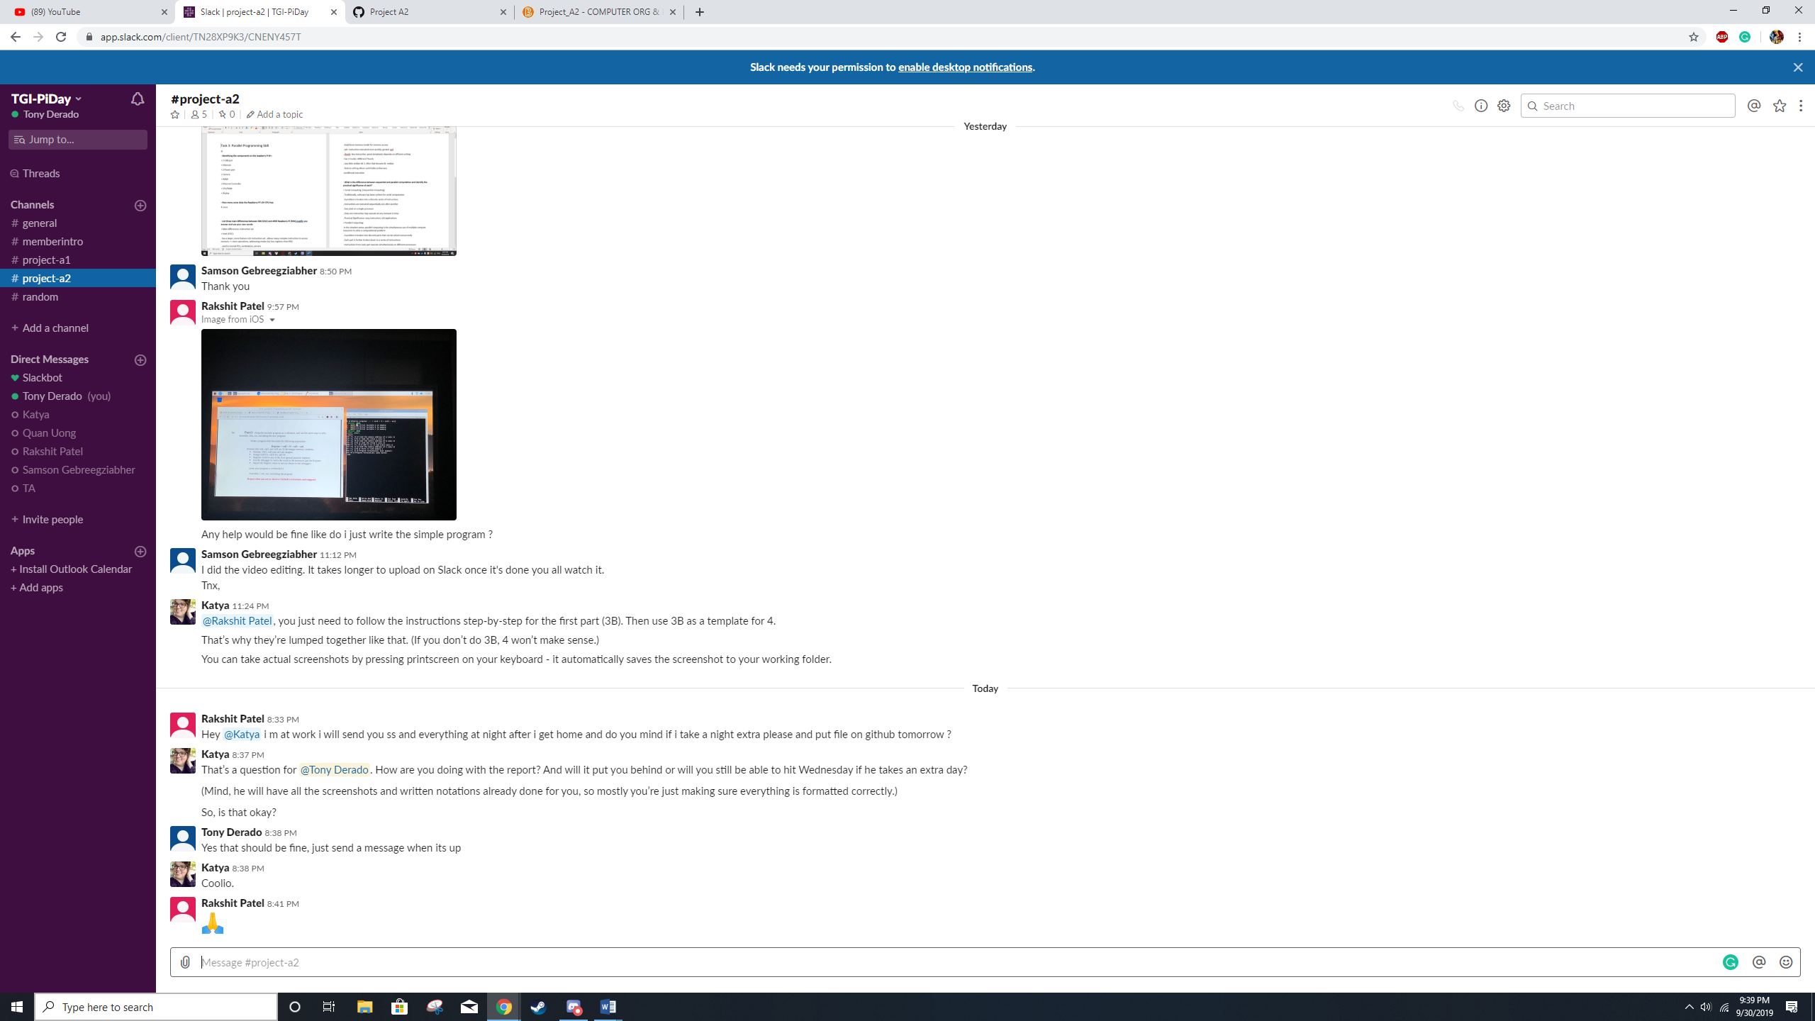

* GitHub: <https://github.com/TGI-PiDay/Project_A1>

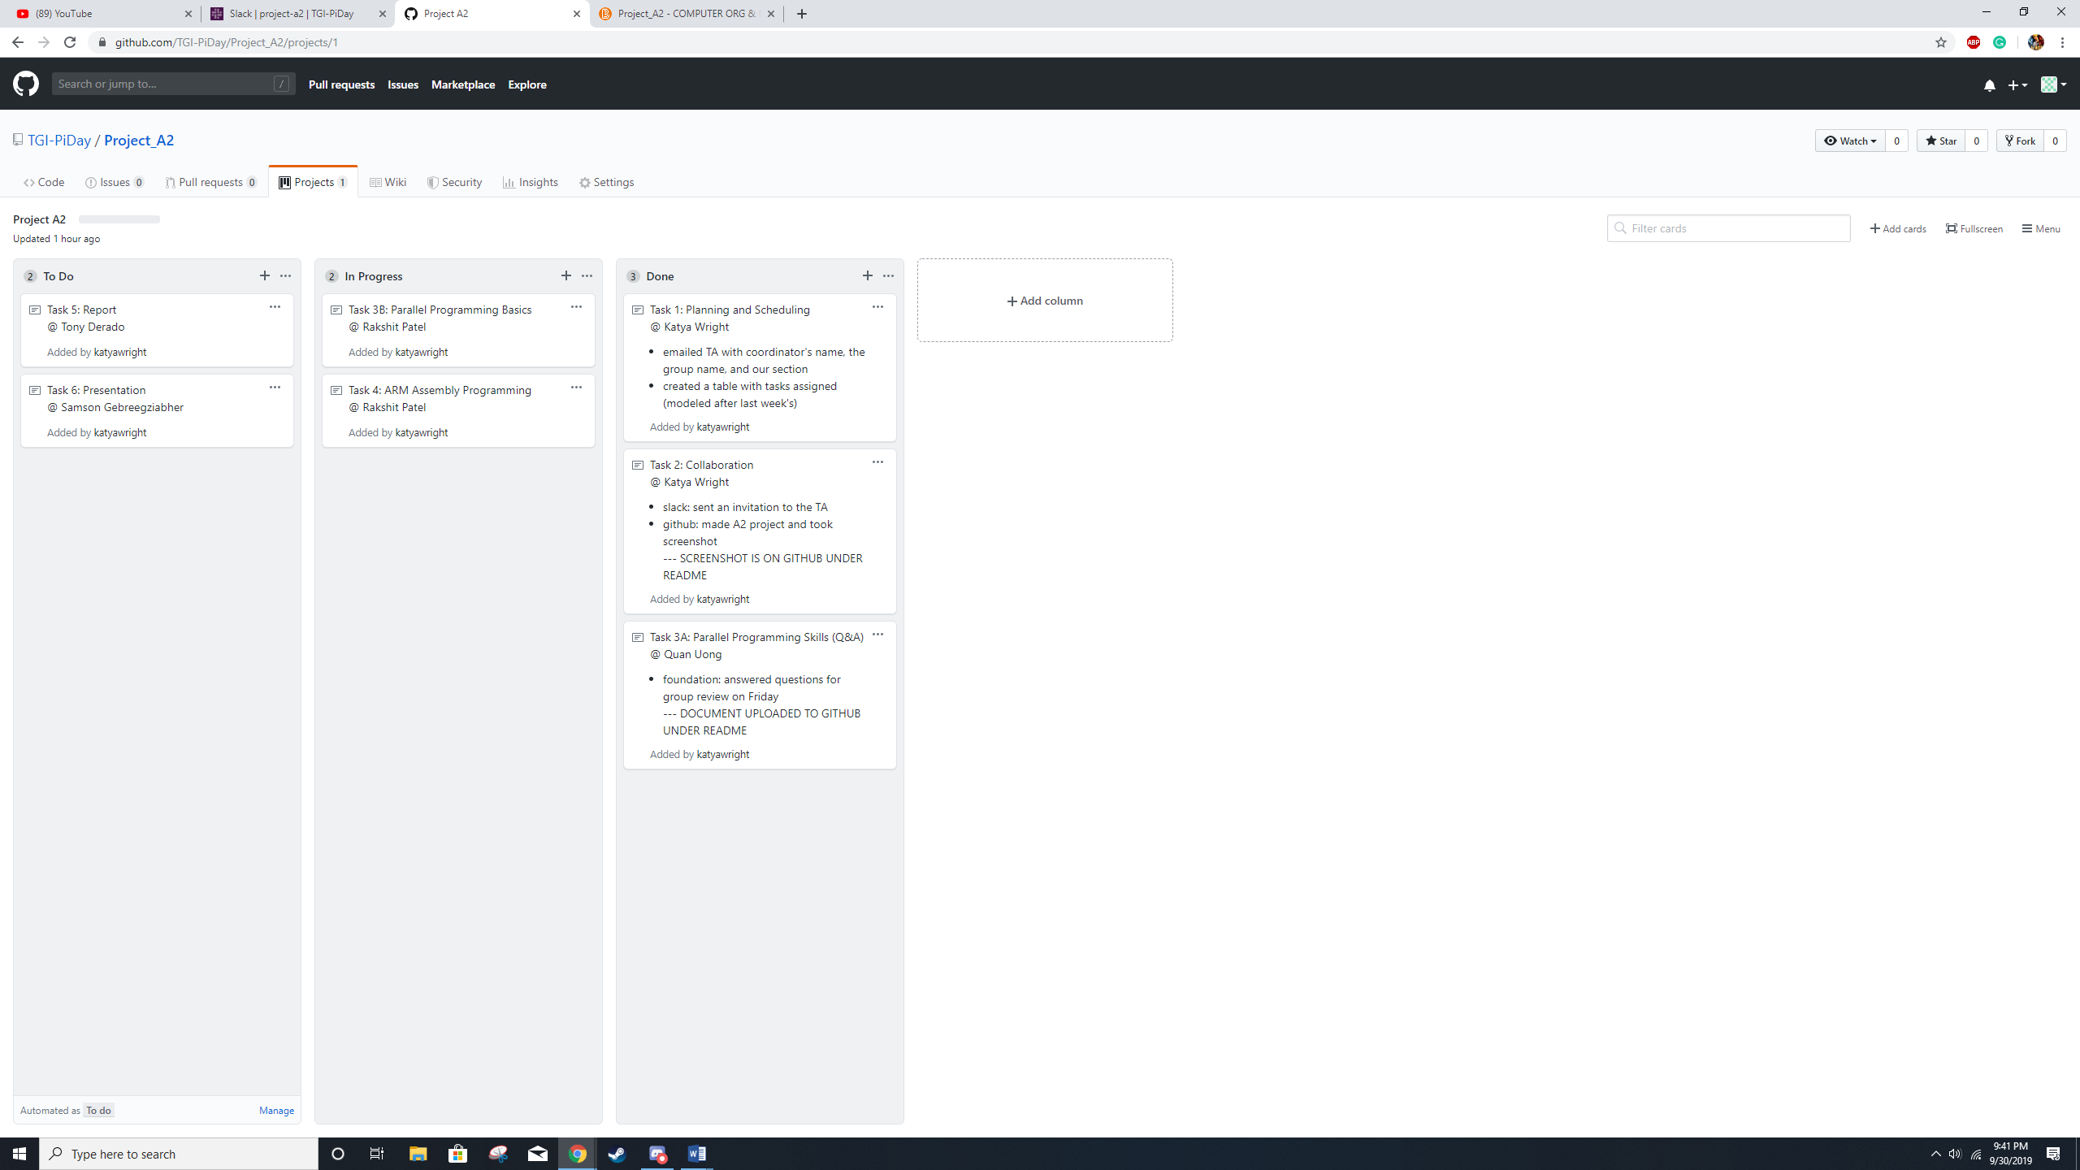

* Video Presentation Link: <https://youtu.be/tPJNEH2jPts>